P235/2
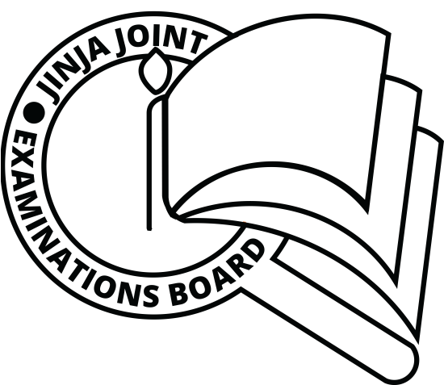
ISLAMIC
RELIGIOUS
EDUCATION
Paper 2
HADITH AND FIQH
AUGUST, 2019
2½ hours

JINJA JOINT EXAMINATIONS BOARD

Uganda Advanced Certificate of Education

MOCK EXAMINATIONS – AUGUST, 2019

ISLAMIC RELIGIOUS EDUCATION

HADITH AND FIQH

Paper 2

2 hours 30 minutes

INSTRUCTIONS TO CANDIDATES:

Answer any FOUR questions; taking at least one from each of the sections A and B.

ALL questions carry equal marks.

SECTION A

1. (a) Account for the collection of Hadith by the Tabiens after the death of the Prophet. (12 marks)
(b) Explain the characteristics of the early compilations of Hadith. (13 marks)
2. Examine the methods adopted by Imam Bukhar in compiling Sahih work of Hadith. (25 marks)
3. Analyze the contribution of Imaam Abu Dauda to the development of the science of Hadith . (25 marks)
4. Examine the conditions which a hadith must satisfy in order to be considered sahih. (25 marks)
5. Examine the intentional and un intentional factors for the fabrication of hadith. (25 marks)
6. Discuss the features that distinguish Hadith Qudusi from Prophetic Hadith. (25 marks)

SECTION B
7 . Account for the development of Islamic Law (Sharia). (25 marks)
8. Discuss the factors that limit the use of Ijma as a source of law. (25 marks)
9. Assess the role of Imam Ahmed bin Hambal to the growth of jurisprudence. (25 marks)
10. Examine the teaching of Islam about the concept of sin. (25 marks)
11. Why is Riba still practiced by many Muslims in Uganda? (25marks)
12. Discuss the challenges to the application of the Sharia in the wake of the current fight against Islamic fundamentalism. (25 marks)

